Automatic Software Plagiarism Detection

Chris Collins

05/04/2006

Final dissertation document submitted to the University of Wales, Swansea
in partial fulfilment for the degree of Bachelor of Science.

Department of Computer Science, University of Wales Swansea.

0. Declarations

This work has not previously been accepted in substance for any degree and is not being currently submitted for any degree.
Name: Chris Collins.
Signed: ..........................
Date: 04/05/2006.
Statement 1
This dissertation is being submitted in partial fulfilment of the requirements for the degree of BSc Computer Science.
Signed: ..........................
Date: 04/05/2006.
Statement 2
This dissertation is the result of my own independent work / investigation, except where otherwise stated. Other sources are specifically acknowledged by clear cross referencing to author, work and page(s) using the bibliography / references section. I understand that failure to do this amounts to plagiarism and will be considered grounds for failure in this dissertation and the degree examination as a whole.
Signed........................
Date: 04/05/2006.
Statement 3
I hereby give consent for my dissertation to be available for photocopying and for inter-library loan, and for the title and summary to be made available to outside organisations.
Signed: ..........................
Date: 04/05/2006.

1. Abstract

This project is an investigation into the process of plagiarism detection for programming source code, with the aim of producing a useful piece of software for detecting unfair practice in this area. The aim is to research the field of plagiarism and its detection and to design and build an application that can detect cheating in source code.

2. Table of contents

0. Declarations 2
1. Abstract 3
2. Table of contents 4
3. Introduction 6
4. Background research 7
4.1. Plagiarism: The problem 7
4.2. Plagiarism in programming source code 8
4.3. Plagiarism detection and anti-detection tricks 9
4.4. Defeating anti-detection tricks 10
5. Research of existing plagiarism detection systems 12
5.1. Ottenstein’s system and its extensions 12
5.2. Method Of Software Similarity (MOSS) 13
5.3. JPlag 15
6. Additional research 16
6.1. The java.lang.reflect library 16
6.2. Java parsing 17
6.3. Class loading 18
7. Initial design considerations 19
7.1. The type of system 19
7.2. The implementation and input languages 19
7.3. The user interface 21
8. Aims 22
8.1. Primary aims 22
8.2. Secondary aims 22
9. Project timeline 23
10. Designing and developing the prototype 26
10.1. Designing the program skeleton 26
10.2. Designing the user interface 27
10.3. Developing the backend prototype 28
10.4. Developing the user interface 29
11. Unforeseen issues 30
11.1. Confusion with class files 30
11.2. Timeline 31
11.3. Class loading 31
12. Testing 33
12.1. Preliminary results 33
12.2. Further testing 34
13. User manual 35
13.1. System requirements 35
13.2. Installing the program 35
13.3. Using the program 36
13.4. Uninstalling the program 37
14. Evaluation 38
14.1. Research 38
14.2. Design 38
14.3. Implementation and development 39
14.4. Testing 39
14.5. Documentation 39
14.6. Project 40
15. Suggestions for further work 42
15.1. Metrics 42
15.2. Automatic source compilation 42
15.3. Structure metrics 42
15.4. Additional input languages 42
15.5. Optimising time and space overheads 43
16. Conclusions 44
17. References 45
18. Appendix I – Source code and Javadoc 47

3. Introduction

This document will outline the entire process taken to develop the software I have created to help detect plagiarism in source code.

Firstly, I will summarise all of my research to date. This will be composed of the initial research I carried out, research done at the midway point to solve problems that I found, as well as further subjects I have looked into to complete my software.

I will write about the design of the system, from the basic design I established, based on my original research, to further design strategies I used to improve the project as it evolved. I also intend to consider my primary and secondary goals, how these were originally obtained and how they changed as the project advanced. The timeline for the project is also a key facet of the task I undertook. I will reflect on my original scheduling decisions and how they were modified as the project proceeded. I will then go over the testing phase, explaining how I tried to ensure that my program was free of errors and also include a user manual explaining how to use the program.

Finally, I will come to conclusions about the entire process that culminated in the most current version of my software, including suggesting how my work can be developed further in the future.

4. Background research

The first part of my project consisted of carrying out background research into the field of plagiarism detection. This was split into subsections dealing with defining the actual problem of plagiarism, how it is achieved and methods to counteract it. I will summarise the main points here and also go into further detail in areas I wish to clarify for the reader.

4.1. Plagiarism: The problem

pla·gia·rism n: a piece of writing that has been copied from someone else and is presented as being your own work (Lexico 2005).

I wanted to look into the reasons that people plagiarised work. I found out that most plagiarism is committed for one (or more) of the five following reasons:

- Time is short.
- Effort is low.
- Someone wants to make an impression.
- There is a lack of understanding of ownership.
- There is a lack of understanding of the subject.

4.1.1. Plagiarising to save time

Time is a valuable commodity: “Time is money”, so wherever some time can be spared, it is likely that some money will be saved. Deadlines are also factors in many areas of work, such as journalism or software development where constraints on the time available to complete a piece of work are often tight. Copying someone else’s work and passing it off as your own takes considerably less time than writing your own piece, so plagiarism is often used to meet a deadline. This is one of the areas that students may be involved in, where coursework deadlines can build up and through poor organisation, plagiarism can be seen as an option to beat the cut-off date.

4.1.2. Plagiarising to save effort

Some people would rather be doing something else than their work, so they choose to avoid thinking about their undertaking and copy it from someone else. They will generally have little interest in the area that their work is in and be eager to get onto something else, perhaps a more interesting task or leisure activity. Due to the fact that this person wishes to make as little effort as possible, it is often the case that they take few precautions trying to disguise their wrongdoing, meaning they are easy to catch. Again, students are sometimes involved in this type of malpractice.

4.1.3. Plagiarising to impress

If you believe someone said something more pertinently than you can put it yourself, you may feel the desire to copy them and claim you thought of it, be it work-related, an anecdote or even a joke. Georgetown University (2005) sum up the futility of this type of plagiarism well in their anti-plagiarism statement: “Learning to write is learning to think. “ It is very rare to have an entirely original thought; however, it is likely that you will have a slightly different take on things to others who have thought before you.

4.1.4. Plagiarising due to a lack of understanding of ownership

Some cultures do not comprehend the concept that in a Western society, ideas are treated as possessions (Austin Community College 2005). Therefore, plagiarists can sometimes carry out their actions without knowing they are doing wrong. Poor labelling of intellectual property can initiate this; with the increasing popularity of the internet where content is frequently not clearly branded, this is a growing problem.

4.1.5. Plagiarising due to a lack of understanding of the subject

Particularly in the field of education, people often simply do not understand the subject sufficiently to write a succinct article, piece of code or other work on the topic. Unfortunately, some of these people would rather risk plagiarism than attempt to understand the topic; another area where students are caught plagiarising.

Now that I had an idea of what plagiarism was, why it is done and who is likely to commit it, I chose to look more specifically at plagiarism in the programming source code.

4.2. Plagiarism in programming source code

Unfortunately, plagiarism is found as much in source code as it can be in more traditional media, such as newspapers, advertisements and books, where breach of copyright has been of concern for years. This is not only of concern to software developers, but also to those involved in education, with students being assessed on the quality of work that they may not have done themselves. Indeed, at this very university in 2003, plagiarism was discovered in the Computer Science Department, where students were found to have submitted near identical pieces of coursework for a Data Structures module (Sharp 2003).

Plagiarism in source code is an increasing problem, due to the increasing availability of the internet. The wealth of source code available online, the invention of online “paper-mills” or “essay banks” (Clough 2000), and the ease of sharing these materials instantly via email or instant messaging are all contributing factors to this escalation in breach of copyright.

4.3. Plagiarism detection and anti-detection tricks

Detecting plagiarism can be a difficult process. By comparing checksums for two documents (running a simple hash function that returns a value based on the content of each document), it is easy to detect exact copies (Aiken et al 2003). However, most plagiarised documents are not exact copies. They can consist of chunks of plagiarised work mixed with some of their own, or even a complete plagiarised document with some words changed to prevent the checksum from flagging the plagiarism. It is much harder to detect plagiarism in these analogous, but not identical sentences.

Comparable practices exist in programming to hide plagiarism, the most common of which is renaming. This is where variables and function names are renamed throughout the program to something else. This can make a program look very different, when it essentially means exactly the same as the source it was taken from. The choices people make for variable and function names are often quite personal and can be used as a good indicator in plagiarism detection, but this anti-detection trick takes this advantage away from the detector. This can be counteracted, but it still makes things more difficult for us, as we can no longer rely on testing for exact matches or variable/function names.

Re-ordering function definitions can also help the plagiarist get away with plagiarism. By copying functions from a source and pasting them in a different order, we are no longer able to test large blocks of code against other blocks, as the plagiarist may have simply defined the functions in a different order (or even just transposed one line elsewhere in the code, such that the output of the program is unaffected).

In my research I also came across a method of plagiarism detection that tests programs for plagiarism based by experimenting with different inputs to the programs and comparing the outputs. The concept of this method of detection is that if a program has similar, uncommon bugs, it is likely to have been plagiarised. This method also has some drawbacks though. If a plagiarist copies a program which gives the correct results with no bugs, then there will be little material for the detector to work with. You are likely to get many false-positives in this case, flagging legitimate programs as copies, purely because they are correct. Adding to this is the fact that these are the programs that the plagiarist is going to want to copy in the first place to get him the highest mark or the biggest pay bonus possible. This method of plagiarism detection is not implemented very often and there is little information available on the subject, so I decided I would not consider it further in my project.

4.4. Defeating anti-detection tricks

I found out that there are ways to get around these techniques and detect plagiarism that has been disguised. These approaches typically involve searching for things that the plagiarist would not normally change, or nullifying the changes that the plagiarist has made. Here are some of the methods that I found out about when carrying out my research into plagiarism detection in software source code.

4.4.1. Obfuscation

This technique counteracts the function and variable renaming strategy taken by the plagiarist. By parsing the code and changing the variable and function names to something generic, we can compare files without considering the impact of changed variable and function names on our results. Obfuscation keeps the “meaning” of the program the same, but alters the actual code; the parallel in the written word would be using a thesaurus to change all instances of a meaning to a particular word (e.g. a plagiarist could copy someone’s work, changing all instances of the word “legitimate” to “legal”. An obfuscator could then determine that “legitimate” and “legal” are referring to the same thing and change both entries to “genuine”, so when compared, the sentences are the same.)

Program 1 | Program 2 | After Obfuscation
my_function() | f() | f1
my_variable | myVar | v1
another_var | var2 | v2
myVar | var3 | v3
function2(String x) | myMethod(String input) | f2(String p1)

Fig 0. Some examples of how obfuscation works.

Obfuscation allows us to consider the actual meaning of the code (the semantics) which will usually not be changed by a plagiarist, rather than the syntax of the code which can be altered whilst keeping the meaning the same.

4.4.2. Stripping whitespace and comments

In most programming languages, whitespace (space, tab and new line characters) has no bearing on the actual output of a program. Whitespace helps make code more readable, but does not affect the meaning of the program. Similarly, comments are not even read by the compiler, so have no affect on the output program, but are only there to aid human understanding of a program. Plagiarists can add, remove and change whitespace and comments to make the program appear different to human and computerised readers. By stripping these semantically insignificant elements from a program, we remove this weapon from the plagiarist’s armoury.

1.
public int add(int x; int y) {
int z = x + y;
return z;
}

2.
public int add(int x;int y){int z=x+y; return z;}

3.
/* This function adds the integers x and y, storing the result in z, then returns z. */
public int add(int x; int y)
{
// Assign z to x plus y.
int z = x+y;
// Now return z.
return z;
}

Fig 1. The above three definitions of “add” are all semantically the same, but with different whitespace and comments.

5. Research of existing plagiarism detection systems

After I had completed my research into the background of plagiarism and its detection, I decided to look into existing systems that attempt to solve the problem and see how they accomplish it. I chose to look at Ottenstein’s attribute counting system and its extensions, plus two tools designed to counteract plagiarism in many different languages: Alex Aiken’s Method Of Software Similarity (MOSS) and JPlag.

5.1. Ottenstein’s system and its extensions

Designed in 1976, Ottenstein’s system primarily involved a process called as “attribute counting” (Malpohl et al 2000). Attribute counting comprises of counting the occurrences of certain articles in a program and comparing the values gleaned with those in another program. Ottenstein used the basic Halstead metrics (Clough 2000) to find plagiarism in FORTRAN code. The Halstead metrics are (Cosma 2005):

- n1 = The number of unique operators.

- n2 = The number of unique operands.

- N1 = The total number of operator occurrences.

- N2 = The total number of operand occurrences.

“Programs with identical numbers of n1, n2, N1 and N2 were considered similar” (Cosma 2005).

Halstead expressed the vocabulary (n) as:

n = n1 + n2

and the implementation length (N) as:

N = N1 + N2

The main problem with attribute counting systems is that the structure of the program is not considered. However, a big advantage is that if the programming of metrics is well designed, you can easily extend the system to make it more accurate. Later attribute counting systems did this, like Robinson and Soffa’s system in 1980 (Cosma 2005). There is also the ability to weight the influence of each metric so that a positive result on one test only adds a little to the suspicion of plagiarism, but another test’s result may mean suspicion is increased by a higher quantity. After running all the tests and considering the weightings for each test, we can then come up with some sort of scale for the estimated likelihood of plagiarism, perhaps flagging files for human inspection that have a probability higher than a certain threshold.

The addition of tests on program structure came when Donaldson, Lancaster and Sposato came up with ACCUSE (Clough 2000). ACCUSE also used a higher number of metrics than previous programs (Cosma 2005, Malpohl et al 2000). Their ideas have been extended upon, with modern systems such as MOSS and JPlag being almost entirely composed of structural tests. Such approaches are known as “structure metric” systems (Malpohl et al 2000).

5.2. Method Of Software Similarity (MOSS)

“MOSS (for a Measure Of Software Similarity) is an automatic system for determining the similarity of C, C++, Java, Pascal, Ada, ML, Lisp, or Scheme programs.” (Aiken 2005). Designed by university professor Alex Aiken, formerly of Berkeley and currently at Stanford, MOSS’s main use has been in detecting plagiarism amongst students’ programming work (Aiken 2005, Clough 2000). This is the same purpose my system is being built for.

Aiken built MOSS with the following properties in mind (Aiken 2005):

- Whitespace insensitivity.

- Noise suppression.

- Position independence.

5.2.1. Whitespace insensitivity

This phase is easily carried out. In nearly all systems where this takes place, it is done simply by removing the whitespace and comments from the input, as I mentioned in my background research. MOSS also considers the obfuscation of variable and function names to come under this heading which is achieved as outlined previously in section 4.4.1.

5.2.2. Noise suppression

Noise consists of the factors that prevent you from getting the correct result. The most important of these is that to prevent many false positive results from occurring, we need to consider that even two completely different programs will contain some similarities. In the written word for example, we could not reasonably accuse one person of plagiarism because the words “the” appeared in their work, as well as that of someone else. A successful plagiarism detection system needs to take this into consideration and only return positive results when significant passages in the inputs are similar (Aiken 2005). In the field of programming there is a similar problem, with many programs likely to contain similar articles. For example, there are likely to be many instances of the reserved words “String”, “int” and “return” in all programs, which needs to be considered. Also, there is the problem of libraries and teacher-supplied code that would throw up false positives if not taken into account. MOSS allows the user to specify passages of code or libraries that are allowed to be found in many input files, where the sharing of code is deemed legal (Aiken 2005).

5.2.3. Position independence

“Coarse-grained permutation of the contents of a document (e.g. scrambling the order of paragraphs) should not affect the set of discovered matches” (Aiken et al 2003). This is how Aiken et al describe the property of position independence. When this is applied to source code, this involves detecting plagiarism even when function definitions are reordered and lines of code are transposed, added and removed.

The concept of k-grams is important in MOSS, where a k-gram is a “continuous substring of length k” (Aiken et al 2003). After whitespace and comments has been stripped, the whole document is split up into overlapping k-grams where k is chosen by the user. These k-grams are then hashed and a small subset of them is chosen, along with information about the document they came from and their position in the document, to represent the document’s “fingerprints” (Aiken et al 2003).

1. Original text:
public int add(int x, int y) {

2. Strip whitespace:
publicintadd(intx,inty){

3. Split into k-grams, with k=5 (5-grams):
publi ublic blici licin icint cinta intad ntadd tadd( add(i dd(in d(int (intx intx, ntx,i tx,in x,int ,inty inty) nty){

4. Hash these k-grams (using some function) to integer values:
2 65 44 22 43 12 62 39 23 10 29 88 45 31 7 87 82 33 64 37

5. Select some subset of these hashes to be the document’s fingerprint, in this example, every 5th:
43 10 7 37

Fig 2. An example of fingerprint creation using MOSS (adapted from Aiken et al 2003).

“If the hashing function is chosen so that the probability of collisions is very small, then wherever two documents share one or more fingerprints, it is extremely likely they share a k-gram as well” (Aiken 2003).

The subset of k-grams to use was sometimes decided by the hashes that are 0 mod p. However, a shared k-gram would only be detected if its hash was 0 mod p. For this reason, MOSS defines a window of size w; a sequence of w consecutive hashed k-grams; choosing one fingerprint from every window in the file. This guarantees the algorithm to “detect at least one k-gram in any shared substring of length at least w + k – 1” (Aiken et al 2003).

This winnowing algorithm has proven to be very successful in the field of plagiarism detection. Due to this, MOSS continues to be one of the most popular detection systems currently in use.

5.3. JPlag

Originally designed to detect plagiarism for Java source, JPlag has since been extended to work with C, C++, C# and Scheme, as well as natural text. It was developed by Guido Malpohl in 1996, originally as a student research project (Malpohl 2005). Guido Malpohl previously worked on MOSS, chiefly in the area of program output, implementing a HTML file output style that can also be seen in JPlag. Similar to MOSS, it is mainly used to detect copying amongst students’ work, but it has also been used by expert witnesses in court cases involving the breach of intellectual property (Malpohl 2005).

JPlag uses an algorithm known as the “Greedy String Algorithm”, introduced in the plagiarism detection program YAP3 by Michael Wise in 1996 (Cosma 2005). This involves an approach called “string tiling”, where the two input programs are split into streams of canonical tokens and the algorithm tries to cover one string by substrings of the other (Malpohl et al 2000). Malpohl et al (2000)’s results indicate that the program is very good at detecting plagiarism. Malpohl challenged people to try to beat his system and the very few that managed to evade detection usually had a horrible structure that would not stand up to human inspection (Malpohl et al 2000).

MOSS and JPlag both use the Karp-Rabin string matching algorithm (Aiken et al 2003, Malpohl et al 2000). The algorithm was created to deal with string matching in genetics to improve the speed of searching for occurrences of a short substring in a much larger string (Aiken et al 2003). It uses k-grams, as explained before, with a rolling hash function, allowing the “hash for the i + 1st k-gram to be calculated quickly from the hash of the i^{th} k-gram” (Aiken et al 2003). This can result in impressive complexities of O(n), considerably faster than other approaches, but the worst case scenario is not affected (Malpohl et al 2000).

From studying these systems I got an idea of the variety of ways that I would be able to build my own system. I got a good background on how they achieved their results in the hope I would be able use some of their ideas, as well as my own in the development of my program.

6. Additional research

As the project progressed and I learned more about the problem, I was required to carry out further research into more specific areas that I had not anticipated at the beginning. This section will outline the reasons why I needed to do extra research and show my findings in these areas.

6.1. The java.lang.reflect library

As I decided I was going to build my project in Java (see later sections of this document on the design of the program, or my initial document for further information), I realised I would need to find a way to get information from either .class files or .java files. The information I will need consists of things like the number of methods etc. for my attribute counting system. I found out that the java.lang.reflect library would enable me to get this information from .class files.

To use the functions available in reflect, the first step is to create an instance of the class I wish to find things out about (Sosnoski 2003). With predefined classes, such as String, this is easy:

Class c = String.class;

“When you use this technique, all the work involved in loading the class takes place behind the scenes.” (Sosnoski 2003). However, if we need to load the class at run time and do not know the class name beforehand, we can explicitly try to find the class in all the ‘usual places’ (defined by the environment variable CLASSPATH) as follows:

String name = “String”;
Class c = null;
try {
c = Class.forName(name);
}
catch (ClassNotFoundException e) {

}

This example should do the same as the first, but this time overtly searching for the class by its name.

We can then use the functions available in the reflect library to get information about the class. For example, the following line of code will get an array of all public Methods in a class:

Method[] methods = c.getMethods();

Now we can call methods on the array elements, such as methods[0].getName() and methods[0].getReturnType() to get the name and return type of a method respectively.

It is also possible to specify a particular set of arguments and return only the public Constructor that takes them as parameters. This example, adapted from (Sosnoski 2003), will return a Constructor that has a String and a Double as arguments (if one exists, else null is returned):

Class[] params = {String.class, Double.class};
Constructor con = c.getConstructor(params);

The java.lang.reflect library was an important factor in my choice of Java as the language in which to program my system, as it is a convenient way to get the information I needed about the programs my system would take as input.

6.2. Java parsing

The above research into the reflect library helped me, but as the project went on, I encountered an issue with class files (detailed in section 11.1 on unforeseen issues). Due to this, I carried out the following research on Java parsing so that I had a backup plan to get the information I needed from .java files instead of .class files.

I looked at tools similar to YACC (Yet Another Compiler Compiler) that used Java as an output language instead of C, as I had previous experience using YACC. I found ANTLR (Another Tool for Language Recognition) and JavaCC (Java Compiler Compiler). These tools create parsers in Java for languages based on a BNF-like (Backus Naur Form) definition file.

I tried ANTLR first and even though it is a good tool, the syntax is significantly different from YACC’s. I decided to investigate other tools before deciding to use ANTLR to see if there were better options available, as I didn’t really want to attempt to define the Java language in a syntax that was unfamiliar to me.

JavaCC, developed by Sreeni Viswanadha and Sriram Sankar while they worked for Sun (Viswanadha 2004), is a similar tool, but with, in my opinion, more understandable and readable syntax. As it is an open source project, many third party developers keep it up to date, as well as the original authors. The main bonus with this tool was that there were many publicly available language definition files (grammar files) on the website, including one for the most current version of Java. This grammar file would not define a parser that carried out the actions I would need, (such as building a symbol table so I could count variables and functions), but would be a solid basis to build my parser on.

I discovered other benefits of using parsing, rather than the reflect library. I would be able to extend my program for use with other input languages much more easily than by using the Java specialised reflect library. You can see that this is one of my secondary aims in my initial document (Collins 2005a).

6.3. Class loading

I carried out this research to solve a problem I was having regarding the loading of classes in Java (detailed in section 11.3)

At runtime, the only Java classes that can be loaded without explicitly loading them (in the way that I showed in section 6.1. “The java.lang.reflect library”) are classes that are in directories that are listed in the environment variable CLASSPATH.

I looked at the Java API and discovered that there is a way to load classes in Java based on the file path to the class file. This was ideal for me, as I would be loading my classes based upon the output of my file choosing dialog. The class I needed was URLClassLoader. Its Constructor takes an array of URLs as arguments, each signifying locations to look for resources: I could get the URL I needed from the parent file of the .class file (i.e. The directory the .class file was in). I would then be able to add this to an array and pass it to the Constructor, in turn enabling me to call the URLClassLoader’s loadClass(String name) method to load the class, gleaning the class name from the name of the file.

7. Initial design considerations

I had to make many decisions when thinking about how I was going to approach the problem. Important decisions needed to be made regarding things like implementation and input languages and the type of system I wanted to develop. Firstly, I made some initial design considerations that I based on my background research and research of existing systems. I could then use these to specify my primary and secondary aims, also establishing a timescale for the project.

7.1. The type of system

The first decision I had to make was concerning the type of system I was going to implement: a metric based attribute counting system, or a structure metric system. I opted for an attribute counting system for a number of reasons. Firstly, with this type of system, I will be able to get a prototype up and running far quicker than with a structure metric system. Also, when I have my prototype and I have created my first metric, it is possible to make the program very easy to extend by adding more metrics, which I will have as one of my secondary goals. Some of these metrics could also test program structure, enabling me to have the best of both worlds, with an easily extensible system that tests with both traditional attribute counting methods and structure metrics. I have already thought of methods to do this in object-oriented programming which I have discussed below.

7.2. The implementation and input languages

The choice of language to I make to implement my system in, as well as the language(s) I wish to accept as input (to test for plagiarism) are important decisions. I had a number of options, including C++, C#, Delphi and Java. I have used other languages in the past, including Haskell and Prolog, but when I chose to implement an attribute counting system, I had some object-oriented ideas about the structure of the program to make it easily extensible.

I could create an interface or abstract class to represent a metric, with actual metrics implementing or extending the class. In this way, I would have some kind of linked list of metrics, each to be tested one by one. To add new tests, I would simply program the new metric and then add it to the list of metrics to be run. I have shown a UML class diagram below to illustrate my point:

Test
int runTest()
countVars
int runTest()
countFuncs
int runTest()

Fig 3. UML class diagram to represent inheritance in metrics classes.

All I need to do to program a new metric is just to extend the Test class and program the runTest() function. As mentioned before, this could include structural tests.

As I have settled on an object-oriented language, now I have to choose which specific language I will use for input and to actually program the system in. These choices are linked, as my choice of input language(s) can affect the language I choose to program in and vice versa. This is due to the fact that it is probably advantageous for the input programming to be the same as the language that I write my system in, as there are sometimes libraries available in a language for getting information about source code in that language. I found that the Java language is very good in this respect, with the java.lang.reflect library being very useful in what I need to do. It is also a language I am very familiar with, so I would likely be able to make good progress and get a prototype program running sooner than if I was using a less familiar language. This means that I will test for plagiarism in Java source code, perhaps extending to other input languages as a secondary goal.

There are other advantages to using Java too. Java is platform independent, so my program should be useable on Windows and Linux machines, allowing portability around the Computer Science department. This is significant, as platform independence was always going to be important, with the department using many different types of computer, so Java will aid me with this. Java also facilitates the use of the Javadoc tool to help me document my program in a clear, concise and easily navigable manner. As I am trying to make my program easy to extend in the future, this will help me (or other programmers) to extend my work in the future. It will also assist me in writing any user documentation that is needed. The final bonus is that students in the first year will be learning Java and using it throughout their course, so my system will hopefully be useful to lecturers and other staff at the university in detecting plagiarism.

7.3. The user interface

The first thing to consider when designing a user interface is the user. This is likely to be someone from the Computer Science department in my case, but that does not necessarily mean that they will be skilled in the use of computers. It may not be the responsibility of lecturers to check coursework submissions for plagiarism, it may be done by the secretaries or someone else who perhaps does not have the experience that lecturers are likely to have using complex systems. Therefore I have decided I will program a GUI interface using the Swing library for Java. Again, I have experience with using Swing, so hopefully this will help me get an intuitive interface running quickly when I do it.

I will probably just program a console application version of my program first, just to test it thoroughly, but if I bear in mind that I want to plug it into a Swing user interface, this should be easy to do at a later stage.

8. Aims

I split my aims into primary and secondary categories. My primary aims were the ones I wanted to achieve first and foremost, with any secondary aims that I could realise being a bonus. These aims may change as the project progresses.

8.1. Primary aims

- The creation of an attribute counting plagiarism detection system for Java, in Java.

- Platform independency (should be inherent from the fact I am using Java, but still a factor).

- The implementation of metrics or tests that return a number that can be used in determining an amount or likelihood of plagiarism.

- To ensure that the system is bug-free and well documented.

- To make the program easily extensible.

8.2. Secondary aims

- To extend the system, adding more metrics.

- To add metrics that deal with program structure.

- The addition of more input languages.

- The optimisation of processing and space overheads.

9. Project timeline

This is my timeline for this project. I constructed this, keeping milestones in mind, such as the completion of the prototype etc. and considering that some things need to be completed before other tasks can be started. For example, I could not start my detailed design of my prototype until I have made initial design decisions. However, other phases could run in parallel: for instance I documented my code as I was writing it.

I also included the deadlines for the initial and interim documents (Collins 2005a and Collins 2005b), as well as for the public presentation at Gregynog and the dissertation, just so that I knew what phase of development I was in relative to these dates.

I stuck fairly closely to the timeline, only running over slightly when I encountered problems finishing the prototype. This pushed back the documentation phase of the project. I also needed to carry out some extra research; I did this in parallel with coding and documenting my program.

The original estimated project timeline Gantt chart is included overleaf, with an amended version showing the actual times taken shown on the subsequent page.
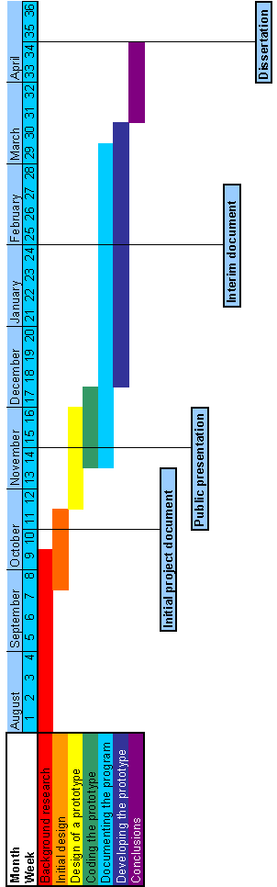
Fig 4. A Gantt chart showing the estimated project timeline.

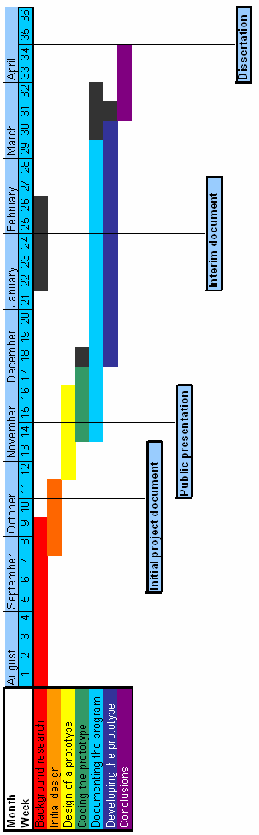
Fig 5. A Gantt chart showing the modified project timeline.

10. Designing and developing the prototype

Now I had made some important decisions regarding the design, aims and the time plan for my project, I could start making a more concrete design for my program.

10.1. Designing the program skeleton

I have already discussed some of the object oriented techniques I wanted to use in the initial design decisions section. Here I expanded on those, using UML to come up with a structure for my program. I chose to design the overall structure first, so that I could come up with a system that would work for many different kinds of metrics. One of my goals was to make the program easily extensible by adding new metrics, so this was at the forefront of my mind when designing the skeleton for my system.

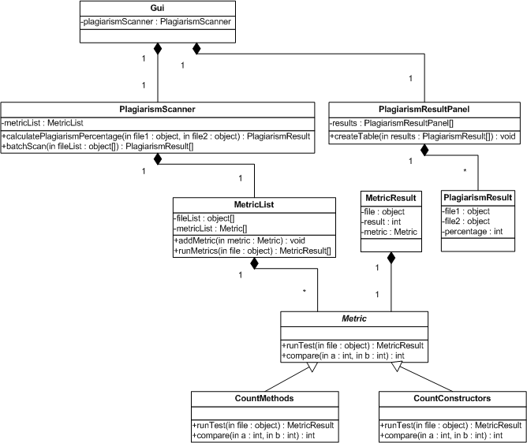

Fig 6. UML class diagram to help me design my system.

As my metric classes (CountMethods and CountConstructors shown as an example) inherit from the Metric class, it is easy to add more tests, just by extending the Metric class and writing the code. Also, (not pictured) I have planned to write a separate package to deal with file issues, such as opening and loading files and class loading. By keeping these functions separate, they are somewhat hidden and once they work, they do not need to be altered, meaning that when the program is growing with the addition of new tests (either by me, or other programmers), this makes the process easier.

I believe the structure I have chosen allows a lot of room for manoeuvre when evolving; many different types of metric could be added, including structural tests. I can now start work on implementing my design for the backend of my program.

10.2. Designing the user interface

As I stated in my initial design decisions, I wanted to use a graphical user interface to allow the user to interact with my program. This was because I felt it was the most suitable way for both experienced and less experienced users to use my system. I designed a basic interface using Sun’s NetBeans IDE, planning to link it to the backend of the program when it is complete. I will also endeavour to keep it threaded, so that long operations are able to complete whilst the GUI is kept up to date.

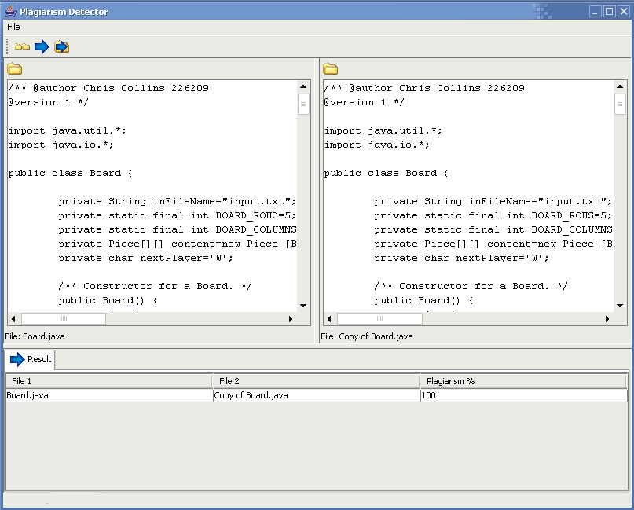

Fig 6. Screenshot of the prototype’s GUI.

There are two JTextComponents in a JSplitPane in the centre of the window. These display the currently opened documents. Once there are two documents open, the blue “Test button” becomes clickable. This will run the selected tests, which I aim to be user configurable when I complete the program. The result is displayed in the lower panel. The user can also do a batch run by clicking the blue arrow with a folder behind it. This will open a dialog where the user can choose multiple files to run the program on. This runs, again, showing the result in the lower panel, on a new tab.

I intend to improve on this prototype and add more functionality at the end of the project, after the majority of the backend programming is complete. This way, if the design of the backend changes, I can adapt my GUI around it.

10.3. Developing the backend prototype

My current structure only allows for metrics that return an integer value, such as the number of methods in a class. This is because one of my primary goals was to implement simple metrics first. More complex metrics which would need two files for input (such as returning the number of functions that had the same parameters when comparing two files) I can implement later. Again, I would make these easy to expand, by writing a super class DoubleMetric that used two files instead of one and extending from that. I would then have a DoubleMetricList class and add an attribute of this type to my PlagiarismScanner class and change the code there to run the DoubleMetrics. Metric result would also need a slight change to be able to accommodate DoubleMetrics, but this is not difficult. Here is a UML diagram of how the system would look with the DoubleMetrics added:

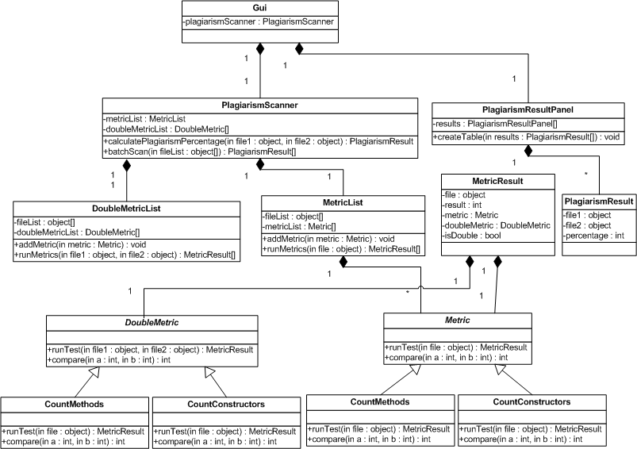

Fig 7. UML class diagram of the system including DoubleMetrics.

10.4. Developing the user interface

As I continued with programming, I kept improving my GUI, making it as user friendly as I could and adding functionality. I added the ability to choose whether wordwrap was enabled in the JTextComponents through a toggle button and added buttons for closing the file in each window, as well as closing both files at once. I also added a status label at the bottom to tell the user what is currently going on and an options panel to customise the tests to use and. I also added buttons to close the options and results panels to prevent the lower pane from becoming cluttered. Here is a screenshot of the more developed interface.

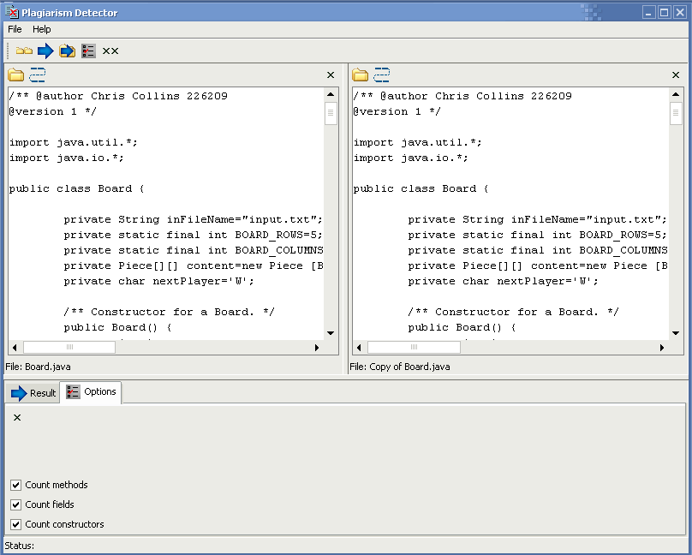

Fig 8. Screenshot of the developed interface.

As previously noted, I will continue development on this interface in the final stages of my project.

11. Unforeseen issues

As with any project, in the implementation phase I encountered a number of problems that I did not anticipate at the start of the project. I detailed some of these problems at the interim phase of the report (Collins 2005b), which I will summarise here. I will also go into more detail about issues that occurred between the interim phase and the completion of the project.

11.1. Confusion with class files

This problem arose just before the interim phase of my project. I wanted to use the reflect library to get the data I needed from programs. However, the reflect library requires .class files to run, which come from compiled .java files. When comparing two files in my GUI, I would ideally be comparing two .java files, as they are in a human readable format and class files are not. Therefore, to display human readable source code and use the reflect library to get information about the program, I need both the source and compiled versions of the program. I had a number of different options as solutions to this problem, each with their own advantages and disadvantages and had to decide which option to go for.

The first thing I considered was removing the reliance on the reflect library altogether. This would mean I no longer had need for .class files, but I would have to find another way to get facts about a program, such as the number of methods. I carried out research into java parsing for this purpose. There were advantages to parsing, such as greater ease of expansion into other input languages, but there were also bad points, such as having to write a lot more code and ending up with something that would not be as robust as the reflect library version.

I also considered not displaying the contents of the file in my GUI at all and just running the reflect library’s functions to get my results. This way, I had no need for source code versions, but the GUI did not show what was being tested. The disadvantage of this is that I would need a compiled version of the program to test it for plagiarism. This program is being built with plagiarism detection for students in mind and not all coursework solutions will compile, due to bugs.

The final thing I considered was to take source code (.java) files as input and display them in the GUI. I would then compile the files and run the reflect libraries on the resulting .class files. My program will still only work on programs that compile correctly, but I am able to display the source code, which is a big plus. Also, I could make the source code editable inside the program, so that small errors could be removed in an attempt to make the program compile. This is probably the most complex option, but it is the most satisfactory solution. I decided to go with this method, so kept the two windows for viewing file contents on my GUI, however, it is currently implemented so that .class files are taken as input and displayed. The automatic compilation of .java files is something that I wish to implement in further versions of my work (see section 15.2).

11.2. Timeline

Due to some of the problems I encountered, I fell behind on my originally planned schedule. I kept up with most things, but when I encountered problems with implementing my design, I was unable to make progress on the programming, which often prohibited me from carrying out the documentation I wanted to do. For example, the above issue with class files prevented me from doing any work on a user guide, as I did not know how the user interface was going to look.

When I solved the problems that were holding me back, I was able to make progress again and catch up to where I wanted to be in my timeline. I had also been slightly stricter than was necessary in my initial timeline so that I had a little bit of leeway if I encountered difficulties. Due to this, I was able to get back on track.

11.3. Class loading

After the interim phase, I was having a problem with my program: the user was supposed to be able to select a class using a dialog box, this class would not already be loaded at runtime. The class files that the user chose would not necessarily be in the CLASSPATH of the machine that the program was being run on. If I could not get access to the class at runtime, I could not run the methods from the reflect library on it.

To solve this, I had to find out more about the way Java loads classes and how to do this at runtime. Through my research, I discovered the URLClassloader class. I then managed to create a function that loaded a class based on the file that was passed to it at runtime and then returned an instance of the class. I could then run reflect methods on the class to get information about it. Here is the function:

public static Class classInstance(File f) {
Class c = null;
try {
String name = f.getName();
String pathMinusName = f.getAbsolutePath().substring(0, f.getAbsolutePath().length() - name.length());
String nameMinusClassExt = name.substring(0, name.length() - 6);
// Directory the .class file is in.
URL[] urls = {f.getParentFile().toURL()}; ClassLoader loader = new URLClassLoader(urls);
// Get an instance of the class.
c = loader.loadClass(nameMinusClassExt); }
catch (MalformedURLException ex) {
// Code omitted.
}
catch (ClassNotFoundException ex) {
// Code omitted.
}
return c;
}

12. Testing

To ensure my program was working, I needed to test it thoroughly. I tested it as I was programming it, to ensure that bugs didn’t “slip through the net” and remain undetected, or difficult to fix when the program was more complex. I also did some preliminary testing on the prototype in the interim phase. After developing the project further, I then carried out another testing stage.

12.1. Preliminary results

In the interim phase, I created a CountFunctions metric as an example, which just returned a random integer. This was just to carry out some preliminary testing, as at this point, the number of functions was not actually being read from the file. I also implemented a compare function for CountFunctions, which returns a high percentage when the results are very close and a low number when they are further apart (100% for an exact match, 50% for within 1, 25% within 2 etc.).

I also altered my program briefly to test that the percentages were being calculated correctly. I forced the CountFunctions metric to output certain values, as shown in the table below. The system produced the expected output for each of the inputs I used it with, as shown here:

FunctionCount 1 | FunctionCount 2 | Expected Result | Actual Result
5 | 5 | 100 | 100
4 | 5 | 50 | 50
5 | 4 | 50 | 50
30 | 32 | 25 | 25
0 | 0 | 100 | 100

I tested equal and non-equal values, extreme lows and highs and whether my program could handle the lower value happening in the first file or the second file. This is because these types of miscalculation are the most likely ones that could occur with my program; so called fencepost errors. I also tested the program with more than one metric to ensure that the metrics were averaged accurately to calculate the overall percentage:

Percentage 1 | Percentage 2 | Expected Avg. | Actual Avg.
100 | 100 | 100 | 100
100 | 50 | 75 | 75
50 | 100 | 75 | 75
25 | 13 | 19 | 19

I decided to round my results (i.e. using the above division algorithm that gives me 100%, 50%, 25% etc., it would never be possible to get 13%; the actual average would be 12.5%). This is because the purpose of the program is to create an approximation of the amount of plagiarism found in a file so that it can be studied closer further by a human if needs be. I do not need the degree of accuracy that comes with using floating point values; I cannot identify the amount or percentage likelihood of plagiarism precisely as I am using my own, arbitrary scale.

12.2. Further testing

One my preliminary testing was complete, I developed the program further and then carried out further testing. At this point I had implemented the metrics more fully so that they actually returned a number based upon their proper function (i.e. The CountMethods metric counted the methods in a class). This testing consisted of looking at existing source code I had written for Java programming courses etc. where I could count the methods in each file. I could then compile this code and run the program on these compiled files. I would then compare the results I got from the program with those I got from doing a manual count of the methods.

When I found that my methods were returning the correct values by using breakpoints and watches in the program, I tested again to make sure that by expanding the program I hadn’t introduced bugs in other sections, particularly the section of code that calculated the overall percentages based on the results of the compare functions from multiple metrics. I did this by repeating the preliminary testing phase on my updated code. The results came out as before, so I knew I had an accurate system.

I also ensured that my GUI was working properly. I used white-box testing: Testing every case that was possible by trying every component in all possible program states. This was not difficult, as there were relatively few program states and the GUI is quite simple. I uncovered a number of bugs which I was able to fix in this way, including one with the wordwrap toggle buttons where both buttons were acting on the same JTextComponent.

The only testing I will need to do is when the program is extended by the adding of more metrics. I will only need to test the individual metric and its compare function and when that is working properly, it will fit into my program in an easy, bug-free manner.

One consideration is if I decide to add the more complex DoubleMetrics discussed earlier. This will mean I will need to carry out my preliminary testing again, both using the traditional metrics and the DoubleMetrics. Once I have got the system working with these, as before, the only testing that will be needed will be carried out on new DoubleMetrics to be added to the program.

13. User manual

My program is relatively easy to use, but I wanted to write some straightforward instructions to use it to be sure that the user is using it correctly. This documentation is based on the most current version of the software, where I have implemented simple metrics and not the DoubleMetrics discussed earlier in the document. I have packaged a .jar file version of my program on a CD and, using a program called exe4j, I have encapsulated it in an .exe file. I did this to improve user recognition of how to run the file, as they may be unfamiliar with Java. Obviously, here I am assuming that the program is going to be run in a Windows environment, but it is still possible to install the system on a Linux based machine, just using the .jar file and the command “java –jar plagiarism_Detector.jar”. I will include instructions for both Windows and Linux: as my program is Java based, it should run on any platform that can run Java, but I do not know enough about these other platforms to give installation instructions.

13.1. System requirements

- A computer with an operating system capable of running the latest version of Java (Windows, Linux, Solaris).

- Java Runtime Environment 5.0 (Available from http://java.sun.com/j2se/1.5.0/download.jsp)

- 100kb of disk space.

- A CD ROM drive.

13.2. Installing the program

The installation process is different for different operating systems. Please choose the section corresponding to your operating system and ignore the other.

13.2.1. Windows

If you have a Windows computer, navigate to your CD ROM drive in My Computer and copy the “plagiarism_Detector.exe” file to your computer. You can now run the program simply by double clicking the file.

13.2.2. Linux

Using the “cp” command, copy “plagiarismDetector.jar” from the CD ROM drive to a location on your hard disk. You can now run the program by typing “java –jar plagiarism_Detector.jar” in a shell opened the folder that you placed the .jar file in, providing your PATH environment variable points at your java/bin directory. Otherwise, navigate to this directory and run the same command, changing “plagiarism_Detector.jar” to the exact path to the .jar file.

13.3. Using the program

These instructions apply to both Windows and Linux environments. Please note: screenshots may differ slightly from your screen depending to your operating system and its settings.

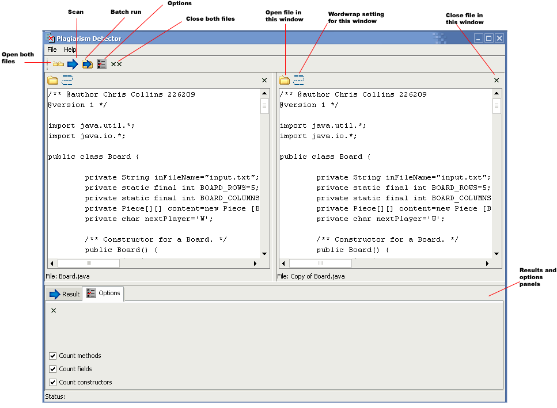

Fig 9. Screenshot showing buttons and their functions.

13.3.1. Single run

To test for plagiarism between two files, first ensure there is a file open in each window. To open a file in each window, click either the “Open both files” button, or the buttons in each window to open a file there. When both files are open, click the scan button and the result will be displayed in the lower panel. You can close this tab when you have finished looking at your results and close the files when you are finished using them, by clicking either the “Close both files” button, or the close button corresponding to the window you wish to close the file in.

13.3.2. Batch run

To run a scan on a batch of files, click the “Batch run” button. Highlight all of the files you wish to test (hold the CTRL key and click them) and then click open. As with a single run, your result will appear in a tab in the bottom panel. Please note: the files you have open in the windows do not affect the batch run option, they will not be scanned.

13.3.3. Customising your test

To change which tests are run, click the “Options” button and choose the tests to run. Tests with checked check boxes will be run; unchecked boxes will not be run.

13.4. Uninstalling the program

13.4.1. Windows

Delete the “plagiarism_Detector.exe” file from your computer.

13.4.2. Linux

Delete the “plagiarism_Detector.jar” file from your computer.

14. Evaluation

To evaluate the success of my project, I have decided to assess the success I had in a number of key areas. These areas include the research carried out for the project, the design phase, the implementation and development phase, testing and the documentation. I will also evaluate the way the project went as a whole, including how well I kept to the deadlines and targets I set myself.

14.1. Research

I feel that this is one of the strongest areas of my project. I carried out a lot of initial research into plagiarism detection, as it was not an area I was very familiar with at the start of the project. I found out a great deal about the background of the subject first and as I continued investigating, I focused my research on the areas that were more specific to my project. For example, I found out about the background of plagiarism, then moved to its detection, then focused on uncovering plagiarism in source code. This narrowing down approach gave me lots of helpful material in the areas that were specific to my project. I used online and paper resources in my research and referenced them accordingly.

I looked at existing systems and the way that they worked to get a good idea of how to solve the problem, learning useful things about plagiarism detection techniques that aided me when I built my system.

When I hit a problem that I could not solve, I carried out further research in the area to solve the problem. Examples of this include researching class loading and Java parsing.

Overall, I am very happy with the research that I did and I believe that it helped me design and implement a good system.

14.2. Design

I was pleased with the design that I did for my project. I designed my project based on a solid foundation of research. I thought carefully before making key decisions, such as which input and implementation languages to use. When I had made these choices, I knew that one of my goals was to make my program easily extensible. I planned my program using an object-oriented approach to achieve this aim. This included the use of UML to design a skeleton system so that it was easy to add extra metrics and different types of tests.

One area that I think I could have improved upon here is the design of my user interface. When I struck problems with needing .class files and .java files for my program to work and to display the information I wanted, my interface was no longer entirely suited to the backend. This remains the case for now, but as I will mention in the “Suggestions further work” part of this document (section 15); I would like to improve the backend of the program. This would entail adding support for compilation of .java files, meaning that my interface would display the .java file and the program would run on the compiled .class file.

I am happy with the design phase of the project, but I felt I could have thought about the user interface a little more thoroughly, perhaps implementing an interface that would have suited both checking for plagiarism in .java and .class files, so that any changes in the backend would not have affected it.

14.3. Implementation and development

This phase take account of the actual programming of the system and how the system evolved as time went on. I was happy with my attitude to programming the solution, building my code on a sound design that would allow flexibility in the future. I used a language that I had experience with and was able to implement my object-oriented design plans with little trouble. I ensured that my program was fully commented to facilitate ease of documentation for the project and to alleviate any difficulties future programmers might have when expanding the system.

I was pleased with the developments I made on the program, improving aspects of the backend and the GUI. However, I would have liked to improve the system further, actually implementing the DoubleMetrics scheme that I designed to increase the accuracy of the system, as there is only so much that can be achieved using single metrics. I consider that I made good progress improving the GUI too, although as I mentioned in the design evaluation, this was to some extent limited by my unforeseen problem with .java and .class files.

14.4. Testing

I carried out two main phases of testing, as well as continually testing my project as it became more elaborate. I was satisfied with the testing I carried out, both at the interim phase and nearer the end of the project and it was more than sufficient for the basic calculations that were going on in the backend involving calculating averages and adding percentages. I also employed white box testing on my GUI to ensure that the components were carrying out the correct actions. There was no need for more extensive testing in this project, so I am content with what I did, resulting in a bug-free system: one of my primary aims.

14.5. Documentation

I am also pleased with the documentation I have done for the project. I have documented all my research and design throughout the project, keeping a record of what has happened throughout the development of my program. I have also kept my program well commented and used Javadoc comments to produce Javadoc HTML files to explain what all aspects of my system to ease future improvements of the system, either by other programmers, or me. This is important, as it supports an important primary aim: “To make the program easily extensible” (Collins 2005a).

As well as documenting the actual project, I have provided a simple user manual for multiple operating systems that details system requirements, installation, program use and how to uninstall the system. Although straightforward, I still feel that this is important, as I have previously stated that the users of the program may not be as proficient with using computers as you might think. I would have liked to have added some kind of online help system too, but the program was not really complicated to worry about this at this stage, but it is definitely something to consider in the future, either by other developers or me if the program grows.

14.6. Project

On the whole, I feel that this was a successful project. I was able to meet the deadlines that were set and I stuck closely to my timeline. At one point, I fell behind slightly with the documentation of the project. This was because of an unforeseen issue that suspended development of the implementation of the program until it was resolved. This did not affect me greatly and I was able to get back on track as I had built redundancy into my project plan by putting some leeway in the timeline to assist me if such a problem occurred.

I achieved all of my primary aims and one of my secondary ones: the addition of more metrics. I would have liked to have achieved more of my secondary goals, especially adding the more complex DoubleMetrics to the system and this is something that I would like to do in time to come. Here is the list of my aims that I set out at the beginning of the project, showing what I achieved (ticked) and what I would like to accomplish with further work (bulleted).

14.6.1. Primary aims

- The creation of an attribute counting plagiarism detection system for Java, in Java.

- Platform independency (should be inherent from the fact I am using Java, but still a factor).

- The implementation of metrics or tests that return a number that can be used in determining an amount or likelihood of plagiarism.

- To ensure that the system is bug-free and well documented.

- To make the program easily extensible.

14.6.2. Secondary aims

- To extend the system, adding more metrics.

- To add metrics that deal with program structure.

- The addition of more input languages.

- The optimisation of processing and space overheads.

I believe that the final product that I produced, consisting of my plagiarism detection system and its documentation, was a good one and is a good basis to build upon in the future.

15. Suggestions for further work

Although I am satisfied with the outcome of my project, there are some areas that would benefit from further work in the future. Here I will list these areas and explain what progress I would like to make in them.

15.1. Metrics

I would like to implement some more metrics in my program. These would be of the DoubleMetric type that I have previously discussed in this document (see section 10.3. “Developing the backend prototype”). These types of metrics would allow more complex comparisons between two input programs but at the same time be easy to add to the program.

15.2. Automatic source compilation

When I have implemented DoubleMetrics, I would like to try to implement the automatic compilation of input source code files. This way, the user could choose .java files as input. These files could then be displayed and would be easy to read (and edit if they would not compile) in the JTextComponents of my GUI. When it came to actually running the program, I would compile the .java files so that the metrics would have .class files to work on. Although I am adding a feature to the program, it may actually make things simpler, as I could compile the .class files to a directory specified by myself, making them easier to find, so perhaps I wouldn’t have any issues loading classes.

This feature would be very useful and one of the things that I would like to concentrate on once I produced the updated metrics.

15.3. Structure metrics

When I have more complex DoubleMetrics, there is the opportunity to add structural tests to my detection program. These would make the system more accurate and useful in detecting plagiarism that has been disguised by code transposition or function reordering. To do this, I would firstly carry out some research into the area of structure metrics, as my research was primarily focused on attribute counting approaches once I had decided to employ this kind of system.

15.4. Additional input languages

I have been using the java.lang.reflect library for many of my metrics and this applies only to Java .class files. However, the structure of my program means that the only modules that involve using the reflect library are the metrics themselves. Metrics could be written to parse other languages and get information about input files that are written in languages other than Java. It would probably mean a reworking of the Metric class, but it is definitely possible.

This is quite a large undertaking and I would probably concentrate on improving the program with Java source code before looking into other languages. It is a very interesting area though, perhaps even going as far as defining some sort of syntax file that can be read by the program to build a parser. This would probably be closely linked with JavaCC, perhaps calling it from inside the program to build a parser, then using a class loader to load the parser into the program. Something this intricate would be a huge task, so I include it only for interest’s sake.

15.5. Optimising time and space overheads

I did not want to start optimising my code until it was nearer completion: as the Donald Knuth once said, “Premature optimisation is the root of all evil.” As I have not put into action all that is possible with the program yet, such as adding more complex metrics, I did not carry out this secondary goal. Once I had expanded on my structure to allow DoubleMetrics, this is definitely something that I would want to carry out as soon as is feasible.

16. Conclusions

This project has shown that it is possible to implement an attribute counting system in Java using Java programs as input. Although my program is not complete and requires the addition of further metrics to give meaningful estimated likelihoods of plagiarism, the system I have built will allow this to be done easily in the future, so I believe the work I have done is worthwhile.

The main area of the project that I had difficulties with was when I encountered my problem with .class files (see section 11.1). In spite of this, I was able to continue making progress and carried out further research to solve this problem, which was very satisfying.

I enjoyed working on this project as it allowed me to carry out my own detailed research and then build a system based upon it to solve a problem. Many tasks I have undertaken before only involved half of the process. These could be assignments asking us to research a particular topic, or to write an already specified program to perform a task. This project enabled me to combine these processes and see how it is possible to design and develop a system around what I have learned through my own work.

I was also able to develop my research, design and programming expertise by carrying out this project, as well as learning the importance of deadlines and goals in project work. These are all valuable skills for the future that I have improved through working on this task.

On the whole, I believe I have created a good piece of software that could be developed to be useful in the future. I have learnt a lot from this project in many different areas and consider it to be a very useful means to learn about software development practices.

17. References

AIKEN, A., 2005. Plagiarism Detection [online]. Stanford University, California. Available from: http://www.cs.berkeley.edu/~aiken/moss.html [Accessed 15 October 2005].

AIKEN, A., SCHLEIMER, S. AND WILKERSON, D., 2003. Winnowing: Local Algorithms for Document Fingerprinting. Stanford University, California.

AUSTIN COMMUNITY COLLEGE, 2005. Faculty Guide to Plagiarism [online]. Austin Community College, Texas. Available from: http://library.austincc.edu/gen-info/facplagiarism.htm [Accessed 14 October 2005].

CLOUGH, P. 2000. Plagiarism in natural and programming languages: an overview of current tools and technologies. University of Sheffield.

COLLINS, C., 2005a. Automatic Software Plagiarism Detection: Initial Project Document. University of Wales, Swansea.

COLLINS, C., 2005b. Automatic Software Plagiarism Detection: Interim Document. University of Wales, Swansea.

COSMA, G., 2005. History of Source Code Plagiarism Detection Systems [online]. University of Warwick. Available from: http://www.dcs.warwick.ac.uk/people/research/G.Cosma/plagiarismhistory2.html [Accessed 15 October 2005].

GEORGETOWN UNIVERSITY, 2005. What is Plagiarism? [online]. Georgetown University, Washington DC. Available from: http://www.georgetown.edu/honor/plagiarism.html [Accessed 16 October 2005].

LEXICO, 2005. Dictionary.com/plagiarism [online]. Lexico Publishing Group, LLC. Available from: http://dictionary.reference.com/search?q=plagiarism [Accessed 16 October 2005].

MALPOHL, G., 2005. jplag.de [online]. University of Karlsruhe. Available from: http://www.jplag.de [Accessed 16 October 2005].

MALPOHL, G., PHILIPPSEN, M. AND PRECHELT, L., 2000. JPlag: Finding plagiarisms among a set of programs [online]. University of Karlsruhe. Available from: http://www.ubka.uni-karlsruhe.de/cgi-bin/psview?document=/ira/2000/1&search=/ira/2000/1 [Accessed 16 October 2005].

SHARP, J.A. (j.a.sharp@swansea.ac.uk), 27 March 2003. [UWS Intranet:] CS121 Data Structures Courswork. E-mail to C.J. COLLINS (226209@swansea.ac.uk).

SOSNOSKI, D., 2003. Java programming dynamics, Part 2: Introducing reflection [online]. IBM, Washington DC. Available from: http://www-128.ibm.com/developerworks/java/library/j-dyn0603/ [Accessed 31 January 2006].

SUN MICROSYSTEMS INC., 2004. Java 2 Platform SE 5.0 API Specification [online]. Sun Microsystems, California. Available from: http://java.sun.com/j2se/1.5.0/docs/api/ [Accessed 30 January 2006].

18. Appendix I – Source code and Javadoc

The source code and Javadoc pages for my program are included on the CD with this document. I have also included compiled versions of my source and a .jar file containing a built version of the project. Instructions for use of the program are contained in section 13 of this document and in the readme file in the Javadoc .zip file.

